Fishing industry perspectives on butterfish
Contributor List (to be added)

ABSTRACT
As part of the butterfish research track assessment, the workgroup is organizing an industry perspectives paper. Staff has provided some initial information (especially for sections 1 and 2), but each section is fully open for reviewing, supplementing, and/or editing. This document will be reviewed and modified with the Mackerel, Squid, and Butterfish Advisory Panel (and interested public), revised accordingly, and then included as an assessment document to help inform overall development of the assessment, as well as its review and use.

ORGANIZATION

1. Historical Fishery

2. Spatial scope of Fishery

3. Availability

4. Catchability

1. HISTORICAL FISHERY
Questions: What’s wrong? What’s missing?
Modern records date to the late 1800s and from then until 1962, catch was made by U.S. fishermen using a mix of fixed (e.g. pound nets) and mobile (e.g. bottom otter trawl) gears harvesting moderate quantities of butterfish - annual catches from 1920-1962 averaged about 3,500 metric tons (mt; 2204.6 pounds) (Waring 1975, Murawski and Waring 1979). From 1963-1986 a foreign fishery harvested butterfish, peaking at over 30,000 mt in 1973. The elimination of foreign fisheries began in 1976 with the commencement of federal/Council fishery management through the MSA. Foreign fisheries declined from over 14,000 mt in 1976 to about 3,000 mt in 1977 with the advent of domestic management and were gradually and fully phased out by 1987 (NMFS 2010, MAFMC 2011). In 2012 Geir Monsen (SeaFreeze Ltd) reported that representatives of Japanese fishing companies had told him that when they were allowed to fish here they caught about 60,000 mt of butterfish each year for a period, but only reported a fraction of their butterfish landings.
The higher volume domestic butterfish fishery developed in the 1980s, primarily driven by one company, SeaFreeze, Ltd, which still catches butterfish today. SeaFreeze developed a frozen export Japanese market for butterfish, supplying high end hot spring resorts with butterfish primarily as a breakfast food. Fish for export have been primarily targeted in the late fall to early winter periods to optimize fat content and minimize feed content. (Perscom Geir Monsen 2012).
The domestic fishery averaged over 5,000 mt per year in the 1980s (NMFS 2010). Catches dwindled in the 1990s, reportedly due to both declines in abundance and market demand issues. Excepting one good year in 2001, landings steadily declined to around 500 mt by 2003 (in the absence of any regulatory constraint). SeaFreeze landed most of those 2001 butterfish and had trouble getting rid of them, attesting to the market issues hindering utilization of the resource (Personal communication w/ Geir Monsen 2012, note low 2001 price in figure below). While regulations did not contribute to the demise of the directed fishery in the late 1990s and early 2000s, trip limits and quotas afterward locked the fishery into a state of a bycatch fishery. Low trip limits were implemented in 2005 and made more restrictive in 2008, while a rebuilding plan was being developed in response to an assessment finding in 2004 that butterfish was overfished (SAW 38). A constraining landings quota of 500 mt was also implemented in 2008 (Table 1) but the trip limits and availability had been limiting landings to around that amount already. Amendment 10 implemented the butterfish cap for the longfin squid fishery in 2010, and the Council’s AP has reported that the longfin squid fishery’s butterfish cap created a general desire to avoid butterfish.
**AP Input on 2005-2012 “bycatch market” A mix of a limited fresh domestic market plus frozen bait for HMS? Anything else?
Regulations/quotas then precluded resumption of a directed fishery from 2005 until 2013, when a limited directed fishery quota was re-established based on empirical analyses conducted by NEFSC staff. The AP has previously reported that from 2005-2013 landings primarily consisted of limited fresh markets and frozen bait. A 2014 assessment utilizing data through 2012 found that not only was butterfish not overfished, but that it had never been overfished, and quotas were substantially increased beginning in 2015 (the assessment review was delayed from late 2013 to early 2014 due to a government shutdown). Geir Monsen in 2012 predicted that “It will take many years to bring the market back and there will be plenty of time to adjust the management if the situation warrants it.” He also noted “Please keep in mind that with a short lived species like butterfish the natural swings in population can be huge. The recruitment can be very strong and the timeline between a stock high and a stock low can be very short.” Ongoing input from the AP has emphasized both the limited markets for butterfish and the potential for rapid changes in butterfish abundance.
**AP Input on re-development of fishery/markets since 2013?

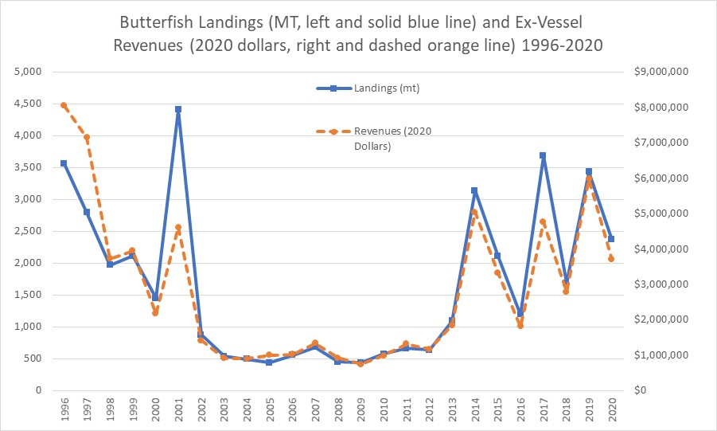

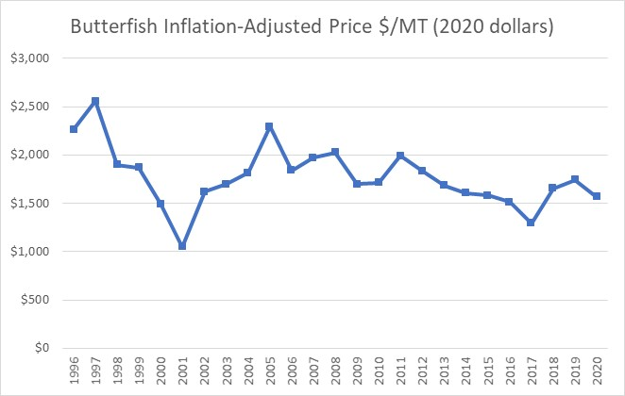

Questions: What’s wrong? What’s missing? Difference between historic and current directed fishery? Thoughts on bycatch avoidance – what were they doing to avoid butterfish?

2. SCOPE OF FISHERY
Questions: What’s wrong? What’s missing?
Fishery observations are limited by the scope of fishing activities in space and time. Fishing activity is influenced by determinants including markets, abundance, availability, regulations, and weather. The figure immediately below was created for Amendment 9 to the FMP with 1996-2003 data, and the next figure following represents a more recent (2018) visualization of landing locations (both VTR data). Given the different methods to create these they are not directly comparable, but there appears to be a general similarity to the range of catch locations across these time periods.
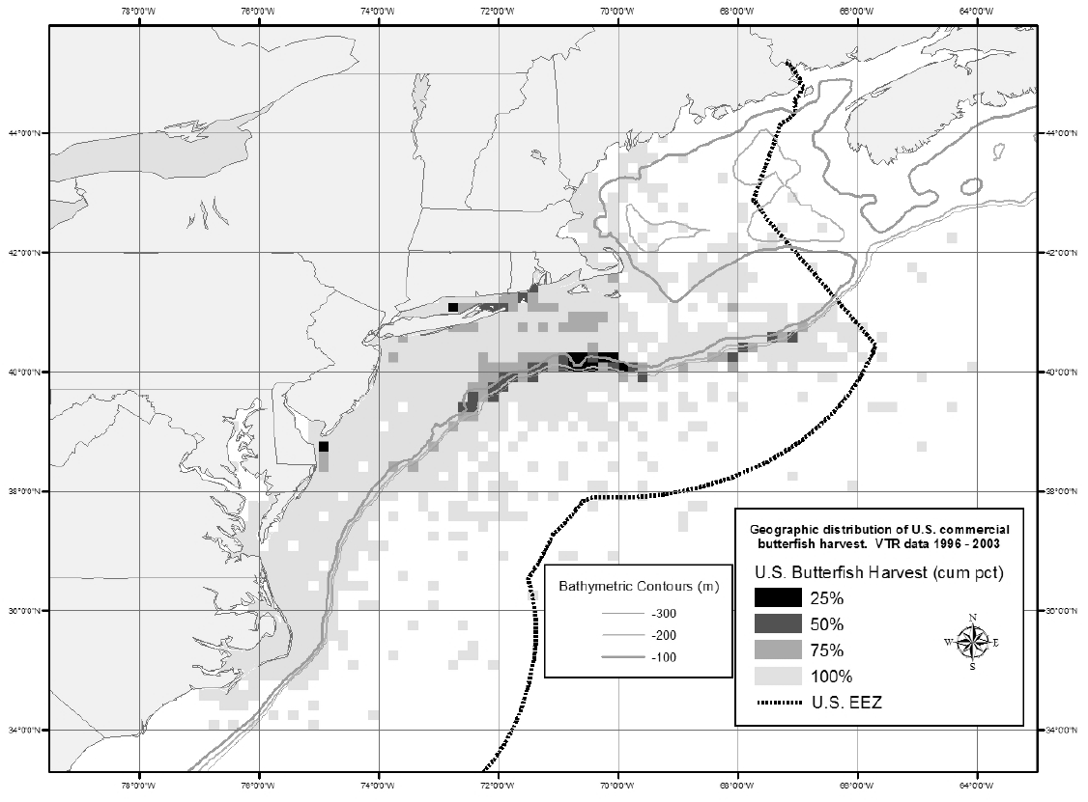
Geographic distribution of butterfish harvest according to VTR data (1996 – 2003).

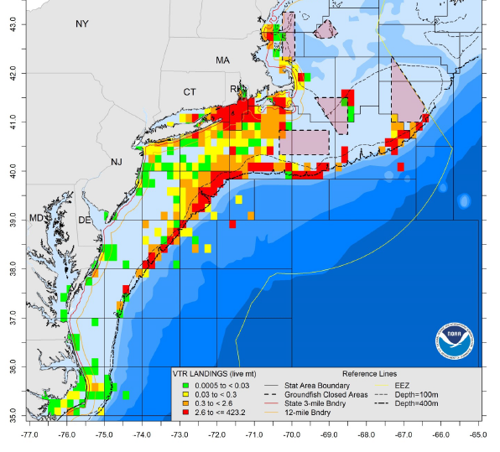
Geographic distribution of butterfish harvest according to VTR data (2018).

3. AVAILABILITY
The EFH Source Document indicates migration inshore in the spring/summer and offshore in the winter north of Delaware Bay. South of Delaware Bay, the winter offshore movement is not as extensive (individuals may move further south but still in shallow water), and limited seasonal inshore-offshore migration occurs south of Cape Hatteras.
Butterfish Smackdown & Environmental Modeling: identified regions and times when butterfish concentrations were likely to be high at scales of 10s of kilometers based largely on thermal preferences. Fishermen understood species-habitat associations at scales much finer than could be described by the data used to construct the model and thus the model itself.
Question for Industry:
What do you think are the most important habitat characteristics (temperature, salinity, depth, prey, predators, water stratification, etc)?
Changes in availability/distribution over time? How stable are fishable locations year to year?
Any additional observations?

4. CATCHABILITY
What creates/effects/limits catchable aggregations?
Offshore
Schooling behavior – water temperature, fronts, bottom features, day/night, water column usage, fish size,…
Acoustic properties
Gear: thoughts on net efficiency, mesh, tow, speed, duration, and other technical challenges…
Thoughts on fish size changes over time.

Inshore (Are they targeted inshore or just mix of retained and discarded incidental catch?)
Schooling behavior – water temperature, fronts, bottom features, day/night, water column usage, fish size,…
Acoustic properties
Gear: thoughts on net efficiency, mesh, tow, speed, duration, and other technical challenges…
Thoughts on fish size changes over time.

