Draft Summer Flounder MSE Model Outputs
May 3, 2022
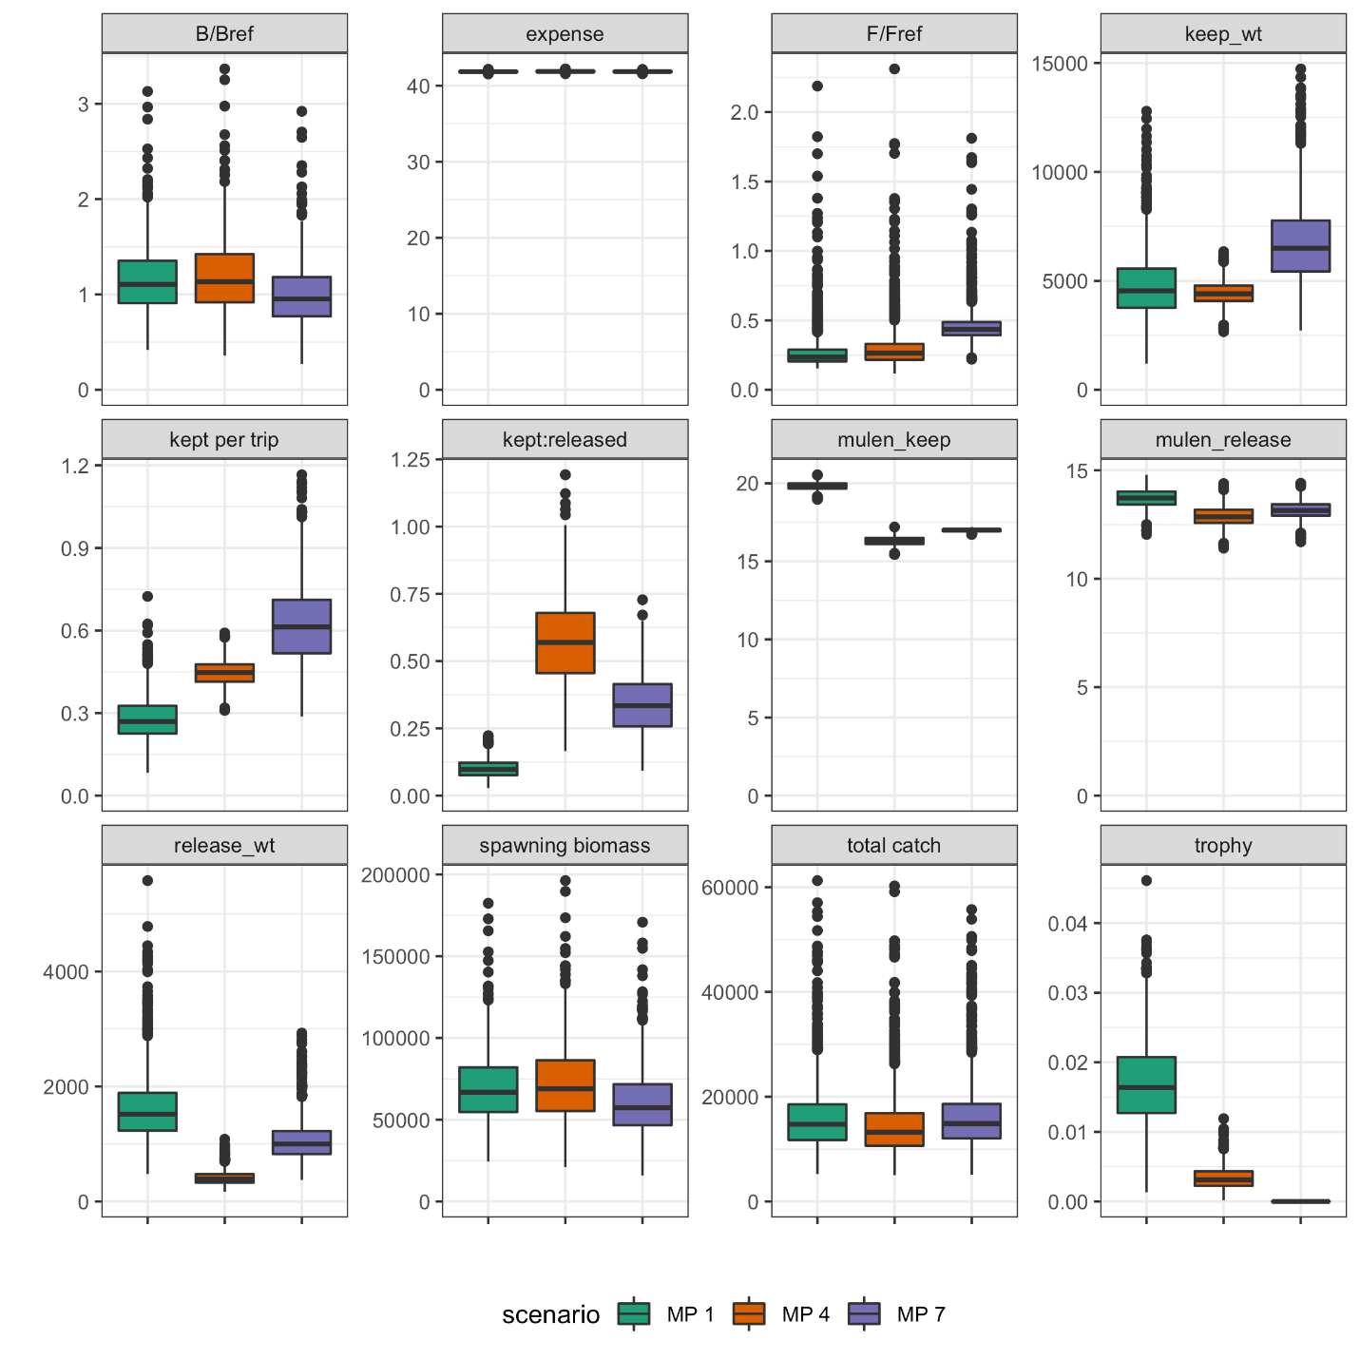

Figure 1. Draft summer flounder MSE box plot model outputs for 12 different performance metrics across three different management scenarios. Scenario MP1 (green) – status quo regulations (2019); MP4 (orange) - 1 fish @ 14” and season from May 15-Sept 15; MP7 (purple) - 3 fish at 16”-20” with season of May 15-Sept 15.
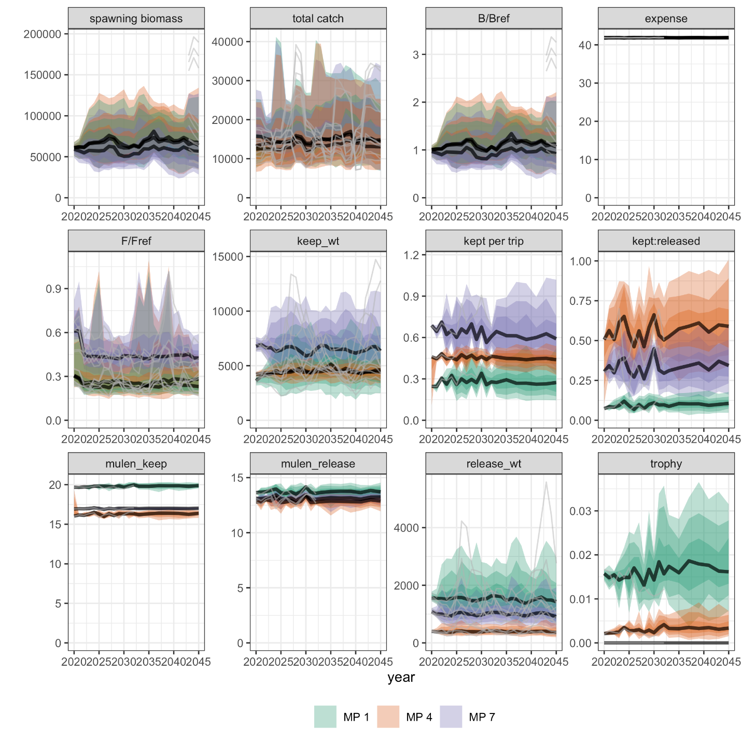
Figure 2. Draft summer flounder MSE timeseries plot model outputs for 12 different performance metrics across three different management scenarios. Scenario MP1 (green) – status quo regulations (2019); MP4 (orange) - 1 fish @ 14” and season from May 15-Sept 15; MP7 (purple) - 3 fish at 16”-20” with season of May 15-Sept 15.
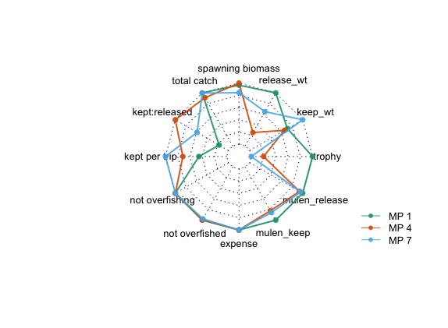
Figure 3. Draft summer flounder MSE spider plot model outputs for 12 different performance metrics across three different management scenarios. Higher values associated with a specific metric are found further out on the plot. Scenario MP1 (green) – status quo regulations (2019); MP4 (orange) - 1 fish @ 14” and season from May 15-Sept 15; MP7 (purple) - 3 fish at 16”-20” with season of May 15-Sept 15.

